**Group 3**

Title: Smart Fridge Application

Students:

Madhur Rajput

Willahelm Wan

**Top level description of the project**:

High Level Functionality: The application is used to track the inventory of the fridge.

Data Domain: Any items that can be kept inside of a fridge.

|  |  |
| --- | --- |
| Users interacting with database | Use Cases/Functionalities |
| **1. Owner of the fridge** |  |
| Inventory management | 1. Add an item to the fridge 2. Remove an item from the fridge 3. Pin an item 4. Display all items by Category |
| Provider management | 1. Add a provider 2. Remove a provider 3. Notification from the providers |
| Promotion management | 1. Display promotions 2. Add promotion to the promotion table 3. Remove promotion from the promotion table |
| Shopping List management | 1. Add an Item to Shopping list 2. Remove an item from shopping list 3. Clear shopping list 4. Display all items in shopping list 5. Price comparison among all providers 6. For each specific item in shopping list, by comparing price from different vendors, automatically cheapest provider per item would be selected for placing an order. 7. Manual ordering items from providers |
| Dynamic Ordering | 1. For all Pinned items whenever the quantity is below the threshold we will decide, those items will be automatically ordered and removed from the shopping list if they are in there. 2. Expiration display will be refreshed accordingly. |
| Processing items management | 1. Track ordered items 2. Add items upon manual ordering or automatic ordering 3. Delete items upon placing the items in the fridge |
| Processed items management | 1. Add items upon placing the items in the fridge 2. Maintain purchase history 3. Delete purchase history |
| Expiration Items management | 1. Retrieve expiration date of all items from the vendor database 2. Items already expired 3. Items that are about to expire (2 or 3 days tolerance) 4. Expiration date would be dynamically fetched from a central database managed by the provider instead of typing in manually. |
| **2. Vendors (for e.g. Amazon, Walmart)** |  |
| Promotion management | 1. Add a promotion 2. Manual removal a promotion 3. Automatic removal of a promotion upon the end date 4. Available items details |
| Product detail management | 1. Add product detail 2. Remove product detail |

**Tools:**

Languages: Java 1.8, J2EE 2.4 for dynamic web module, SQl, PL-SQL, Javascript, Struts2 framework for development

Web application server: Apache Tomcat 7

Build tool: Maven

Database: MySQL

**Interest**:

This is a real-world example of an application that we can use in our daily life.

Feedback Questions:

1. Can the app be used by multiple devices/household members ? Will changes made by one member be visible to the others? Will the changes/updates be performed such that it preserves data accuracy and consistency for all users ?

No, currently there is only one user for the app. In real life, most likely it will only request one user since the fridge is only used by one family. We will try to add the functionality that will allow multiple users, just in case there are multiple families using the same fridge. If we add this functionality, then the other users will be able to see the changes made by other members. For example, on the inventory display it will display a drop down menu of all the users. Other users can see each other’s inventory. They would not be able to order items with each other’s account because authentication is required. The data accuracy and consistency will not be affected.

2. Related to the above point consider building a notification system from the App ?

Yes, there would be a notification display panel on the display.

3. Does the app allow ordering items from the vendor ? Would the promotions be applied on ordering?

Yes, multiple vendors can be configured for items selected for automatic ordering; also, while manual ordering user has an option to select from multiple vendors based on lowest price and days to deliver the product.

4. Are you going to consider multiple vendors? Order from a given vendor depending on the promotion for that week? Once the order is received, are the quantities of the items going to be updated.

Yes, multiple vendors are there. Promotions would be applied when user is searching an item for ordering (for e.g. if there is discount, user would see the final price after discount). Once order is received items would be updated in the inventory.

5. What about storing the history of previous transactions, consider using this information on both the vendor side and consumer side.

Purchase history is maintained on the user side but not on vendor side.

6. Make every effort to have a well-functioning backend, with enough attributes to capture the workflow for all the use cases, implementing complex business rules and normalizing your databases. Ensure relevant checks are implemented to ensure data accuracy and consistency. Make use of SQL functions, triggers, stored procedures wherever appropriate.

Yes we have implemented procedures and triggers and will implement rest of the objects as we proceed.

2. An UML diagram of the database which you will be using for the project. This diagram should contain attributes, entities (at-least 8-10 entities), relationships, multiplicity, and primary/foreign keys. You can use any diagramming tool you prefer. One that is freely available is [https://creately.com/ .](https://creately.com/) You should plan on using this image during your class project presentation as well as in your final project write-up (where it will be graded more strictly and worth more points). (3 Points MySQL , 4 Points NoSQL).

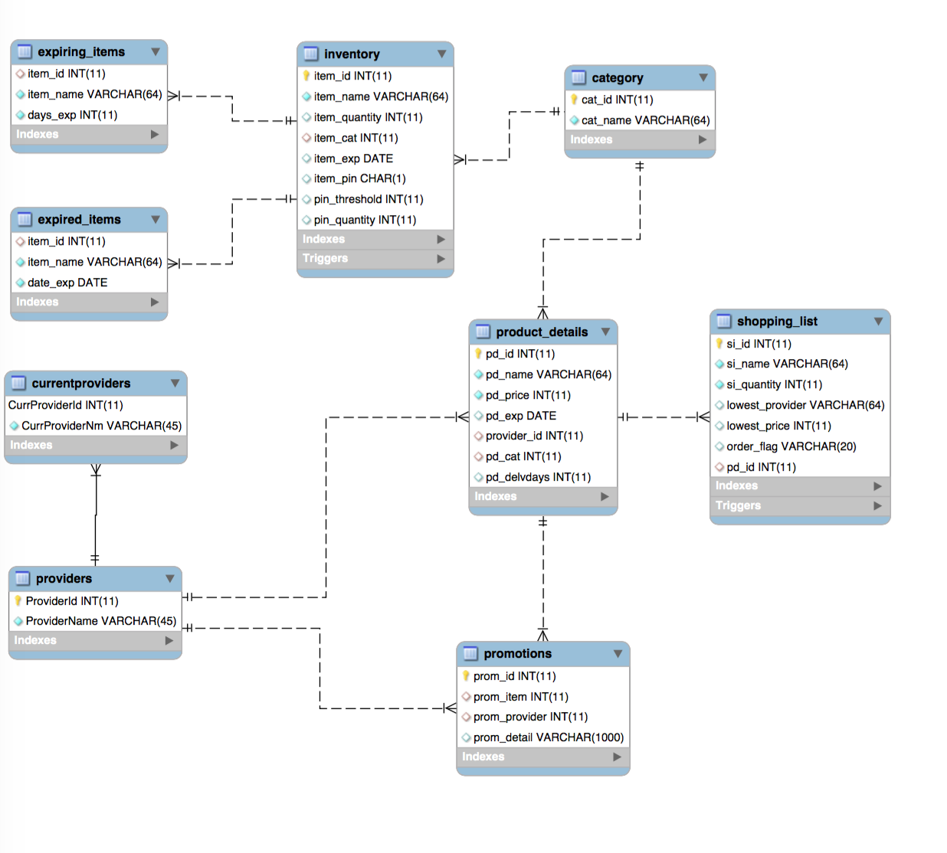

3. An EER diagram converting the UML diagram to a relational schema. Please use the MySQL

Modeling tool. If you are using NoSQL you do not need to submit this. (1 point MySQL)

***Note: What you need to submit is the relational model only which is worth. You can create it using the MySQL workbench tools. 4points***

Please refer to question 2.

4. A brief step by step user interaction of your application, including all CRUD operations (create, read, update, delete) you plan on implementing for the project. The description should list the steps a user would require to perform in order to use your application. A flow chart is sufficient. For students who know what an activity diagram is, please include an activity diagram **INSTEAD OF** the steps mentioned above. (3 Points)

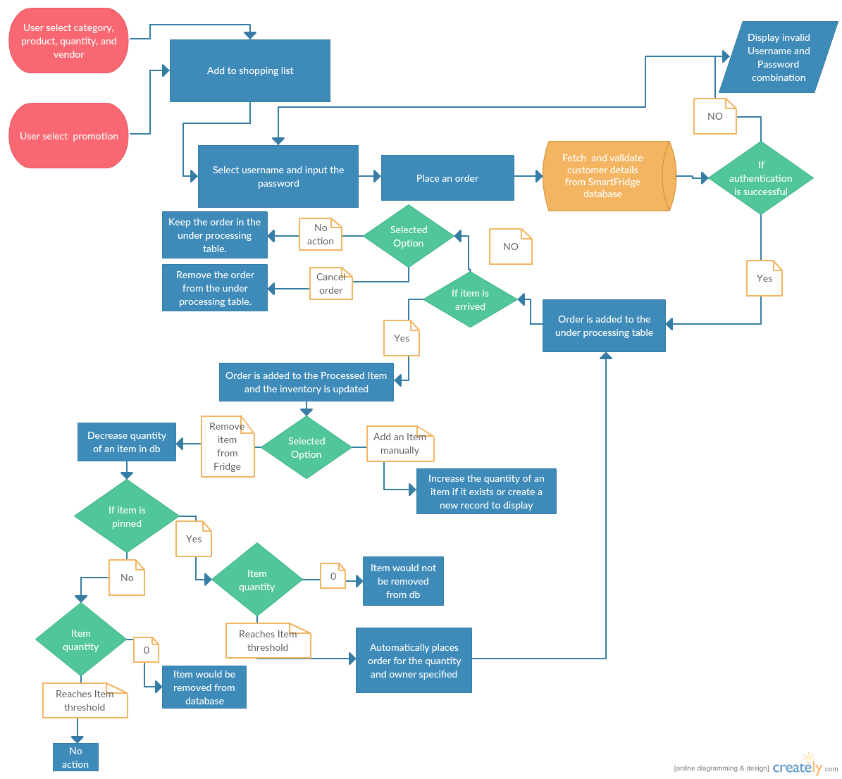

5. A final decision on the technology used to create the project. Please include details such as toolkits, libraries, backend languages, front end languages (name and version), web technologies and database connectivity. Please make sure that you include the specifications in a separate section titled **Technical Specifications** within the progress report. If you included the specifications within your original proposal reiterate them here (cut and paste of the text is fine). (2 points)

Languages: Java 1.8, J2EE 2.4 for dynamic web module, SQl, PL-SQL, Javascript, Struts2 framework for development

Web application server: Apache Tomcat 7

Build tool: Maven

Database: MySQL